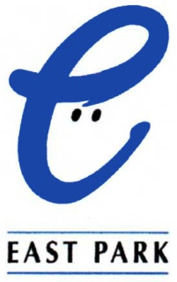

Information for applicants for
Membership of East Park Board of Directors

August 2015

Contents

Who We Are 2

What We Do 2

The School 2

Supported Accommodation 3

The Respite Service 3

Workmates 3

The Care Team 4

East Park Philosophy 5

East Park Professional Development and Training……………………… 6

Person Specification – Board Member 7

East Park – Recruitment and Selection Policy Statement 9

Contact Information 9

Who we are

East Park has provided Education and Supported Accommodation services to children and young people with additional support needs, including autism, since 1874. Our philosophy reflects current legislation, best practice and a commitment to excellence. All our services focus on the needs of the young people and encourage partnership with the child and family.

East Park is regularly inspected by the Care Inspectorate, Education Scotland and as an accredited service with the National Autistic Society. East Park is also an SQA Approved Centre.

East Park has received positive inspection reports from all the above bodies since 2012. All inspection reports are available on the website at www.eastpark.org

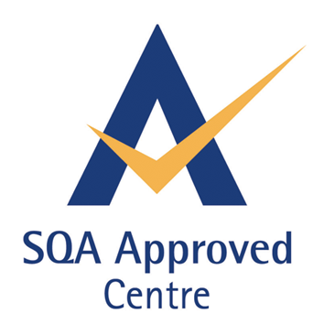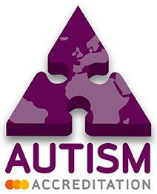

What we do
East Park strives to provide excellent, person centred residential care and education to children and young people with complex additional support needs, including Autism Spectrum Disorder, physical and sensory impairments, and challenging behaviour, between the ages of 5 and 25. With the young person at the centre and working with external partners, our work focuses on seeking innovative, personalised approaches which enable each individual to reach his or her maximum potential.

East Park provides four main services:
- Education (day & residential)
- Supported Accommodation (52 weeks)
- A post-school ‘Workmates’ programme for young adults aged 18-25.

The School

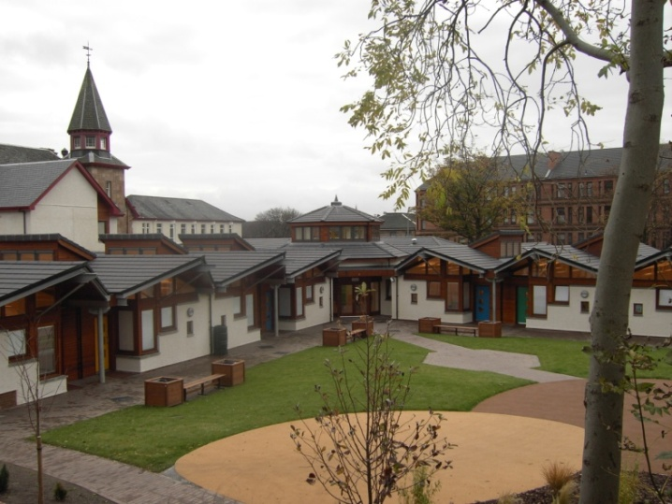
East Park School provides education to children and young people between the ages of 5 and 19, with additional support needs. All pupils have a significant learning difficulty coupled with additional disabilities including physical disability, sensory impairment, ADHD, Attachment disorder, ASD and challenging behaviour. Around 80% of the pupils are on the autism spectrum and require specialist techniques and strategies in order to minimise the impact of their barriers to learning. East Park provides comprehensive and appropriate learning environments and opportunities for this group of children/young people, for example through:


- Personal learning plans
- Individual and group teaching and learning
- Elaborated curriculum based on Curriculum for
Excellence

- Sensory curriculum
- Post-eighteen education
- Links with colleges and other schools
- Specialised resources and equipment
- Use of community facilities and amenities
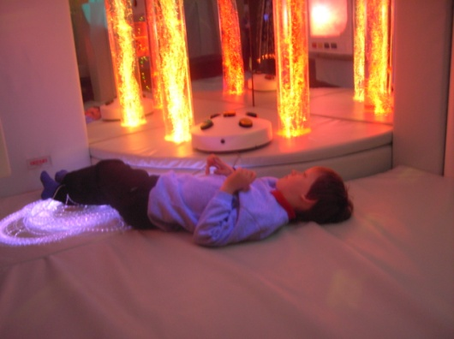

Many of the young people are non-verbal communicators, many may require intimate & personal care, the majority have no sense of danger, and all require a high staff ratio to enable them to access fully the curriculum and community.

East Park provides a child-centred curriculum which provides opportunities for the young people to have a range of relevant experiences and achieve positive outcomes.

Supported Accommodation

East Park has four high specification purpose-built houses located within pleasant residential areas of the local community. The houses each accommodate 4 or 5 young people in single occupancy bedrooms. The location of our houses allows young people to live socially valued and fulfilling lives as part of the community, experiencing neighbourly relationships and having full access to local community activities and resources.

Workmates

“Workmates”, East Park’s supported Education and Supported Employment Service is designed specifically to support young adults with high support needs, aged 17-25.

Workmates offers an individualised service to young adults. High support needs generally would be classed as requiring at least 1:1 support to sustain a meaningful experience in the workplace or college.


The service provides opportunities for:
- Continuing and further education
- Vocational training
- Development of independence
- Career development
- Supported work experience and employment

Workmates works with each young person as necessary, either directly supporting a placement or in the planning process. This may increase over time as occupation increases, or may decrease as natural supports are
developed.

Each student benefits from a unique package of support appropriate to his/her needs. Workmates provides opportunities for growth and development to enable individuals to enjoy a fulfilled lifestyle. The benefits to the young people include:
- A wider circle of relationships
- Development of natural supports
- Different supports from those normally experienced

The Care Team

All our care staff are appropriately qualified and registered.

Every resident young person has a key worker who acts as a designated link person co-ordinating all aspects of their care. The key worker supports the young person both on a day to day basis and in relation to the planning and reviewing process, to express their views and choices and to fully participate in all decisions which may affect their lives.

Recognising the importance and benefit of a consistent approach, particularly in relation to supporting young people with autism spectrum disorders, the care team works closely with the education team to develop and implement effective strategies.

In East Park these, specific individualised strategies which support the young person throughout the day and across settings are incorporated into the following joint processes and procedures:

- The young person’s Personal Organiser
- Their Behaviour Support Plan
- Their Autism Support Plan
- Their Personal Learning Plan
- Individual Progress and Planning Meetings
- Class planning and timetables
- Individual activity planners

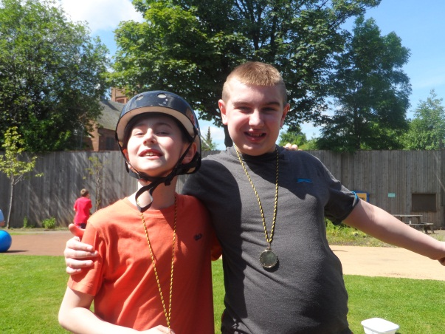
East Park Philosophy

The 24 hour curriculum

All members of the East Park team recognise that learning opportunities constantly arise from every day experiences and activities and are not restricted to the school day. Care staff facilitate on-going learning and development by participating in both school projects and themes and in the development and achievement of joint targets agreed at Individual Progress and Planning meetings.

Reflecting the objectives and values of Curriculum for Excellence and Getting It Right for Every Child (GIRFEC) we aim to support young people to be healthy, achieving, responsible and effective contributors by providing meaningful social and recreational activities which promote the development of life skills and independence.

Working with others

We consider genuine effective team work to be at the heart of ensuring best outcomes for young people. East Park staff work in close partnership with social work staff, health professionals, LD CAMHS teams, etc. We particularly value our relationship with family members and carers. Central to all of this is the young person whose input and views are pivotal to all decisions made in relation to his/her life.
Transitions
All of us experience transitions in our lives and while these can be both exciting and challenging, we recognise that for young people with a learning disability and/or autism, transitions are often overwhelming.

One of the underpinning objectives of the work of the Care Team is to support young people to develop social, emotional and self-care skills, which will help them prepare for life in the adult world. Taking account of young people’s individual needs and aspirations, our staff promote continual achievement and development, provide young people with positive relationships and positive life experiences, promoting self-determination and feelings of self-worth and striving to improve outcomes for them by supporting them to be all they can be.

East Park Professional Development & Training

East Park is fully committed to supporting the learning and development of all colleagues. By providing qualifications and on-going learning and development opportunities to persistently raise the standards of the care and education we provide, we continually refine and affirm the development of a positive ‘Lifelong Learning Culture’ at East Park.

We pride ourselves in being a high quality training resource for the continuous development of our workforce. East Park supports colleagues to gain a wide range of qualifications from Post Graduate Certificates in Autism Studies to mandatory H&S qualifications.
As a Scottish Qualifications Authority Approved Centre we deliver the workplace and academic qualifications required by the Care Team to register with the Scottish Social Services Council (SSSC).

We provide a comprehensive programme of induction and continuous training through our blended learning approach, combining on-the-job instruction, in-service training, online courses, external provision and self-directed learning to meet our skills needs.

New employees undertake a programme of formal and informal training which will continue throughout their time with East Park.

Training is provided in a wide range of subjects and our mandatory provision includes Child and Adult Safeguarding, Moving & Handling and Fire Safety.

Our comprehensive approach to training ensures our provision meets, and where possible exceeds, the standards required by our regulatory bodies including the Care Inspectorate, Education Scotland, SSSC and Autism Accreditation.

East Park’s Training Team

The training delivery at East Park is organised and managed by the Training Department which is staffed with two professionally qualified and experienced members, as well as design and delivery input provided by highly skilled professionals from across our services.

EAST PARK BOARD MEMBER
PERSON SPECIFICATION

Listed below are the skills, knowledge and personal qualities you will need to undertake the role of a member of East Park Board.

ESSENTIAL CRITERIA

You must live or work in Scotland and be available to attend regular meetings in Glasgow. You should demonstrate:
• an empathy with the needs and challenges faced by children and young people with additional support needs including autism, and a commitment to their on-going support;
• an appreciation of education and/or health and social care policy and/or the rules governing charities and how they might impact on the role and aims of East Park;
• the ability to challenge constructively, and influence, decision-making within a Board or team setting;
• the ability to develop, monitor and meet strategic objectives through effective planning and resource management;
• the ability to analyse and review complex issues/opinions and make your own decisions;
• a commitment to the values of equal opportunity and diversity, to a culture of respect for others, and to partnership working; and
• the ability to build relationships and interact effectively with others.

DESIRABLE CRITERIA

• Senior experience in education and/or social or residential care, experience in finance and/or accountancy, experience in promoting fundraising and support, experience in the delivery of estates projects.

ROLE AND RESPONSIBILITIES

The purpose of the Board is to ensure the efficient, effective and accountable governance of the organisation and to provide strategic leadership and direction to East Park’s Executive Director and senior management team.

Along with the Chair, Vice Chair and other members, you will support the provision of education and care to children and young people with additional support needs including autism.

You will be expected to support the Chair and work with the other members to discharge the functions of the Board, which will comprise:
• regularly attending and actively participating in Board and other related meetings;
• developing strategies which address the service priorities and needs of the organisation;
• contributing to the effective performance of the Board and ensuring achievement of its aims;
• allocating resources to address strategic objectives and ensuring the financial health of the organisation;
• monitoring implementation of Board decisions; and
• ensuring sound governance arrangements and probity and propriety in the workings of the organisation

In addition you will:
• maintain a focus on strategy and performance;
• actively participate in collective decision-making;
• act on the principle of collective responsibility for decisions of the Board;
• question intelligently and debate constructively;
• listen sensitively to the views of others, inside and outside the Boardroom;

• communicate and support the Board’s activities whilst encouraging and maintaining good relationships with stakeholders:
• challenge and support members of the senior management team in their leadership of the organisation while monitoring performance; and
• uphold the highest ethical standards of integrity and probity.

TIME COMMITMENT

As a non-executive member you must be able to make a firm commitment to spend time on Board business. This time will mainly be focussed on Board & Committee meetings but will also include reading documents in your own time.

You may be asked to support additional activities, potentially attending stakeholder events some of which may be in the evenings or at weekends.

A degree of flexibility is required in order to attend additional Board meetings, subject to the on-going needs of the Board.

LENGTH OF APPOINTMENT

The term of appointment will be for three years with the eligibility of re-election for two further periods of three years. Appointment may be renewed subject to evidence of effective performance and the requirements of the person specification for the role at the time of re-appointment.

EAST PARK – Recruitment & Selection Policy Statement (all posts)

East Park is committed to providing a high quality service within a safe and nurturing environment, so that children and young people can thrive in the knowledge that they will be listened to and will be protected from harm. Fundamental to this is an effective and reliable workforce. For this reason East Park is committed to a rigorous and safe recruitment process. We aim to attract quality applicants and above all to recruit the right people.

In order to do this our recruitment and selection policy and procedure may entail some or all the following thorough and robust checks for:

- Identity
- Birth Certificate
- Passport
- Driving Licence
- Utility bills for address

- Suitability
- PVG Enhanced Disclosure
- Written application
- Performance at interview
- Health declaration
- Eligibility for registration with the Scottish Social Service Council (SSSC) or equivalent regulatory agency
- Meeting the criteria of the Job Description and Person Specification

- Capability
- References including, if required, checking any listed previous employer as well as designated referees
- Performance at interview
- Health declaration
- Educational/professional qualifications including viewing of original certificates
- Meeting the criteria of the job description and person specification

Equality and Diversity
All of the above will be underpinned by East Park’s commitment to the principles and values of equality and diversity. East Park recognises that a more diverse workforce better reflects the diversity of the young people we serve and the multi-faith and multi-cultural society in which we live. We therefore welcome applications from all eligible individuals including those from minority ethnic groups and those with disabilities.

Contact Information for Board Applicants
Kenneth Pinkerton, Chair of the Board
Judy Cromarty, Executive Director

East Park, 1092 Maryhill Road, Glasgow, G20 9TD Tel: 0141 946 2050 www.eastpark.org.uk
Contact for initial enquiries Laura Brown HR & Administration Manager

Email: lbrown@eastpark.org.uk

Informal visits are encouraged; please contact as above
Start date: As soon as possible subject to satisfactory references and PVG check

REGISTERED CHARITY (SC012838) (Company Number: SC356976)

East Park is an equal opportunities employer regulated by
the Care Inspectorate and Education Scotland

